Client | i2i Systems
Project Name | TeleCell Remaining Balances

Table of Contents
1 Document Overview 3
1.1 Scope & Purpose 3
1.2 Version Numbers 3
1.3 Audience 3
1.4 Document Structure and Special Conventions 3
1.5 Definitions, Symbols and Abbreviations 4
1.5.1 Definitions & Terminology 4
1.5.2 Abbreviations 4
1.6 References 5
2 Overall Design Considerations 6
2.1 Assumptions 6
2.2 Prerequisites, Restrictions and Constraints 6
2.3 Design Methodology 6
2.4 Open Issues and Risks 7
3 High Level Architecture 8
3.1 Database Connection Class 9
3.2 Subscriber Entity Class 9
3.3 Services Class 10
3.4 ServicesDao Class 10
4 Low Level Architecture 12
4.1 creatıng web Service project 13
4.2 Login Service 38
4.3 Create User Service 39
4.4 Get Balance Service 41
4.5 Show Profile Service 42
4.6 Change Password Service 43
5 Interfaces & Integration 44
5.1 Interfaces and Integration Map 44
5.2 External Interfaces Map 45
5.3 System/Solution Interfaces Map 46
6 Deliverables Portfolio; Applications and Libraries 47
6.1 i2i developed Applications and Libraries 47
6.2 3rd Party Applications and Libraries 49
Appendix 50
Document Control 50

Document Overview

Scope & Purpose

The scope of this document is to provide a main system/solution architectural specification (SAS) for revealing the architectural and design characteristics of the system/solution of the [TeleCell] project.
Note that for complex systems/solutions where many modules/applications that work in harmony must be constructed, this document serves as the MAIN architectural design document. In such cases, a module/application specific design document per module/application is to be prepared during implementation and shall be verified by the Architecture Authority.

Version Numbers

This Specification has been produced by the i2i Technology and Consultancy (i2i) following 3GPP specifications alike versioning scheme.

The contents of the present document are subject to continuing work and may be changed by i2i. Should the i2i modify the contents of the present document, it will be re-released with an identifying change of release date and an increase in version number as follows:

Version x.y.z
where:
x the first digit:
1 presented for information;
2 presented for approval;
3 or greater indicates approved document under change control.
y the second digit is incremented for all changes of substance, i.e. technical enhancements, corrections, updates, etc.
z the third digit is incremented when editorial only changes have been incorporated in the document.

Audience

The document may be read by the below audience;

- Business/System Analysts
- Solution/System Architects

Document Structure and Special Conventions
If the document is complex and specific sections apply to specific reader profile, a brief description of vital sections contained in the document shall be provided.
Such as;

Section X: Explains the details related to xyz providing diagrams. This section shall be read by Business Analysts
Section Y: Explains the details related to wqv from system perspective. This section shall be read by Solution Architects
Etc.

Definitions, Symbols and Abbreviations

Definitions & Terminology

This section provides a common list of definitions considering the Turkish/English terminology.
Turkish | Entity Name | Description
Bayi Yonetimi | Dealer Management | Refers to all customer specific dealer management tasks such as Dealer Activation, Takeover etc.
Bayi Yonetimi – Basvuru | Dealer Application | An application form is filled for the actual activation/ official registration of a dealer. Dealer Application triggers back-end workflow process that considers Customer specific business rules and approval mechanisms.

Abbreviations

TERM | DESCRIPTION
API | Application Programming Interface
ASN.1 | Abstract Syntax Notation 1. An abstract syntax notation, which is used to describe data and data structure.
BGW | Billing Gateway
BRS | Business Requirements Specification
BSS | Business Support System
CDR | Call Data Record – Records in files generated by external network nodes such as MSC, SDP etc.
DWH | Data Ware House
EDIFACT | Electronic Data Interchange For Administration, Commerce and Transport. EDIFACT indicates a format
EIR | Equipment Identity Register
FMS | Fraud Management System
GUI | Graphical User Interface
HTML | Hyper Text Markup Language.
HTTP | Hyper Text Transfer Protocol. Simple stateless protocol used throughout the internet.
IVR | Interactive Voice Response System
Java | An object orientated programming language which is portable between platforms.
MML | Man Machine Language, specifies the command format API of the HLR
OSS | Operations Support System
SAS | System Architectural Specification
SOAP | Simple Object Access Protocol  SOAP is a simple XML-based protocol to let applications exchange information over HTTP
SRS | System Solution Requirements Specification
VAS | Value Added Service
XML | Extensible Markup Language. A widely used standard mark-up language.
XSD | XML Schema Definition. XML Schema is an XML based alternative to DTD. An XML schema describes the structure of an XML document.

References
- SRS_SystemRequirementsSpecifications_[Area]_[ProjectCode]_v1.1.5.doc, System Requirements Specifications, Jan 2014, i2i-Systems
- NFS_NonFunctionalSpecifications_[Area]_[ProjectCode]_v1.1.4.doc, Use Cases Specification, Jan 2014, i2i-Systems

Overall Design Considerations

Assumptions

Describe any assumption, background, or dependencies of the system/solution, its use, the operational environment, or significant project issues that impact overall design

- Abc
- Abc

Prerequisites, Restrictions and Constraints

Describe any constraints on the system that have a significant impact on the overall design of the system. (e.g. technology constraints, performance requirements, end user characteristics, validation requirements, project constraints, etc.)
- Abc
- Abc

Design Methodology

Summarize the approach that will be used to create and evolve the designs for this system. Cover any processes, conventions, policies, techniques or other issues which will guide design work.

Open Issues and Risks

Describe any notably volatile or risky areas of the system and not any special strategies taken to mitigate risks or prepare for changes.

High Level Architecture

Descriptions of Login, Create User, Get Balances, Show Profile, Change Password functions and Subscriber entity, Service, ServiceDao and Database Connection sections in the project are available below.
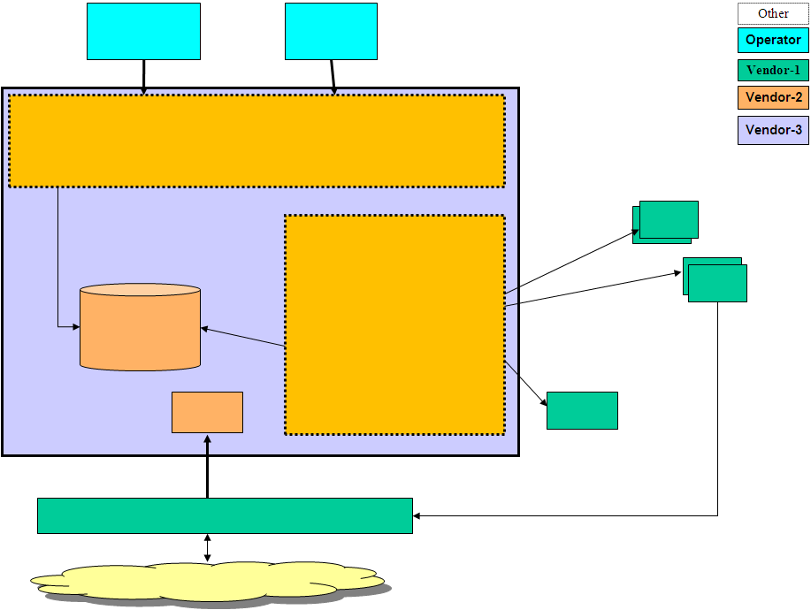
Figure 1: High-Level Architecture

Database Connection Class

Database Connection is made as follows and connection is provided where necessary.

public Connection connect() {
Connection connectionDB = null;
try {
DriverManager.registerDriver(new oracle.jdbc.driver.OracleDriver());
connectionDB = DriverManager.getConnection("jdbc:oracle:thin:@localhost:1521:XE", "SYSTEM","1234");
System.out.println("Bağlantı Başarılı...");
}
catch (SQLException e) {
e.printStackTrace();
}
return connectionDB;
}

Subscriber Entity Class

By creating this Subscriber Class, the operations to be done will be done through the subscriber object to be created. The variables necessary to create a subscriber are defined in the class, getter and setter methods, an empty and a full constructor are defined.

private String fullName;
private String phoneNumber;
private String email;
private String password;
private String birthDate;

public Subscriber() {

}

public Subscriber(String fullName, String phoneNumber, String email, String password, String birthDate) {

this.fullName = fullName;
this.phoneNumber = phoneNumber;
this.email = email;
this.password = password;
this.birthDate = birthDate;
}

public String getFullName() {
return fullName;
}

public void setFullName(String fullName) {
this.fullName = fullName;
}
.
.
.

Services Class

There are Service functions in this class. In some of these functions, the format control of the incoming parameters is done. The function sends the relevant response to the place where the Service request is made after the transaction.

public int login(String inputPhoneNumber, String inputPassword) {

int result;
Subscriber subscriber = new Subscriber();
subscriber.setPhoneNumber(inputPhoneNumber);
subscriber.setPassword(inputPassword);
result = getServicesDao().login(subscriber);

return result;
}

ServicesDao Class

Database operations are done in this class. CallableStatement Object is used in order to use the defined procedures in the database.

public int login(Subscriber subscriber) {

CallableStatement csProcedureObject = null;
int result;

try {

csProcedureObject = this.getConnection().prepareCall("{CALL CHECK_USER(?,?,?)}");

csProcedureObject.setString(1, subscriber.getPhoneNumber());
csProcedureObject.setString(2, subscriber.getPassword());
csProcedureObject.registerOutParameter(3, Types.INTEGER);
csProcedureObject.execute();
result = csProcedureObject.getInt(3);

}

catch (SQLException ex) {
ex.getMessage();
result = FALSE;
}

finally {
try {
csProcedureObject.close();
connection.close();
}

catch (SQLException e) {
e.printStackTrace();
}
}
return result;
}

Low Level Architecture

The Web Service part of the project takes the necessary parameters and ensures that the database connection is made and the result value is transmitted to the requested place. In this section, there are Services such as Login, Create User, Get Balances, Show Profile and Change Password. Control of the incoming parameters in the Login, Create User and Change Password sections is provided and if it is not in the desired format, '0' is sent as the return value. In case of success, the value '1' is returned. In other Services, the parameter to be entered is the phone number, the return values are the usage rights remaining in Get Balance, and the User Profile Information in the Show Profile.

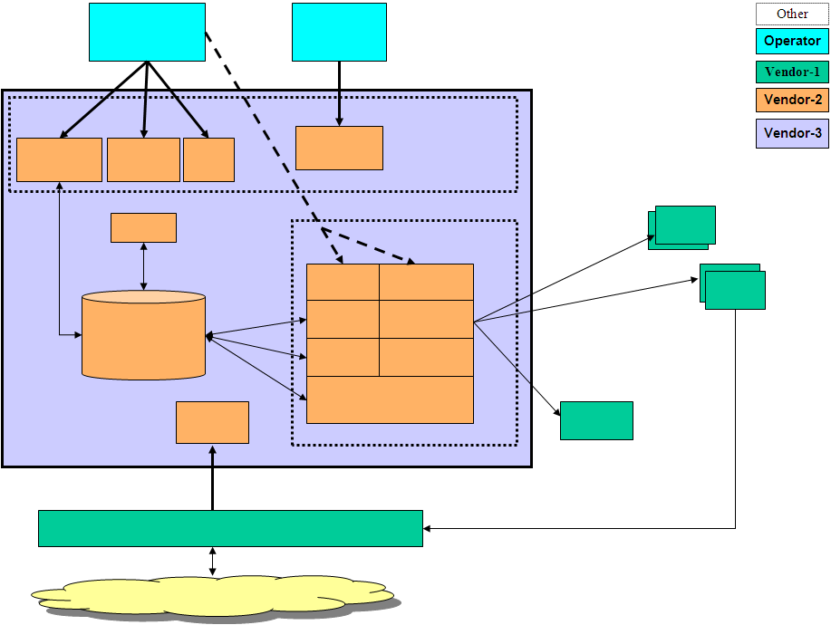
Figure 2: Low-Level Architecture

Creating Web Service Project

Prerequisites for creating Web Service in Eclipse environment, Web Service Installation and Testing;
Module Properties | Property Details
Name | TeleCell
Module Category  (Application / Library / Other ) | Application
Module Type  (PLSQL / EJB / WebService / Standalone / Library/Web Server) | Web Service
Shipment Type  (JAR / EAR / WAR / BINARY EXE / SCRIPT / (UN)WRAPPED PLSQL) | War
Interaction Type  (Synchronous/Asynchronous) | Asynchronous (with web browser on client side)  Synchronous with TeleCell (Database)
DB Dependency | YES
Expected Latency | ~50ms
Access Level  (Public / Non-Public / 3rd Party) | Internal
Input | Creating and Testing Web Service in Eclipse environment
Output
Main Processing  Logic | After downloading and installing Eclipse and Apache Tomcat 9.0 follow the steps below to create a Web Service Project.

- Download Axis2-1.7.9 and copy it to C:\ before creating the project. Open Eclipse and go to Preferences from the Window option and load the file as indicated below.
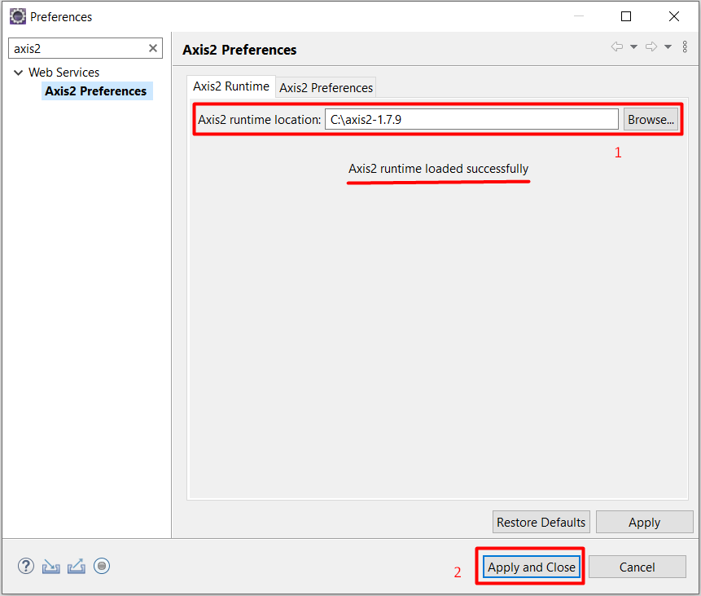

- To create the project, click new from the file option and select Dynamic Web Project.
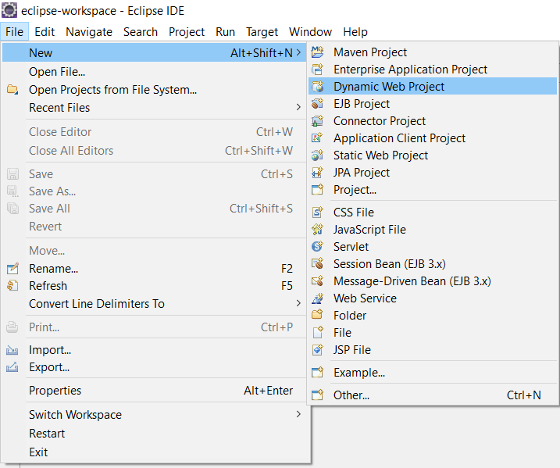
- Perform the following steps to configure the project.
- Click the Modify tile to install Axis2.
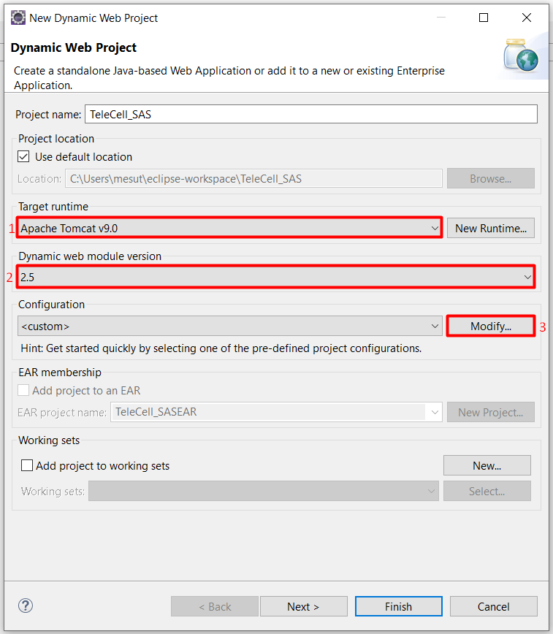

- Add Axis2 to the project and confirm. Then click the Next button to skip the steps and click the finish button to create the project.
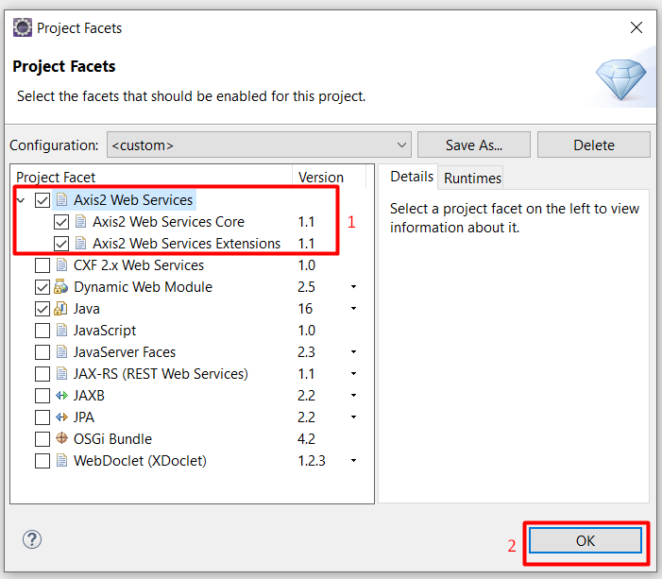

- Proje oluşturulduktan sonra aşağıdaki gibi dosyalarımızın oluştuğundan emin olalım.
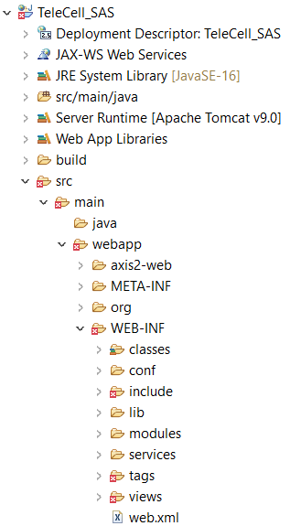

- To eliminate the errors seen above, download the .jar files shown in the picture below and copy them into the lib (TeleCell_SAS \src \main \webapp \WEB-INF \lib) folder in the project file.

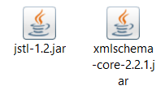

- After performing this operation, you will see that the errors have been fixed.

- Download the ojdbc8.jar file to make the Oracle Database connection in the project.
- Right click on the project you created, click Properties, and then follow the steps given below.
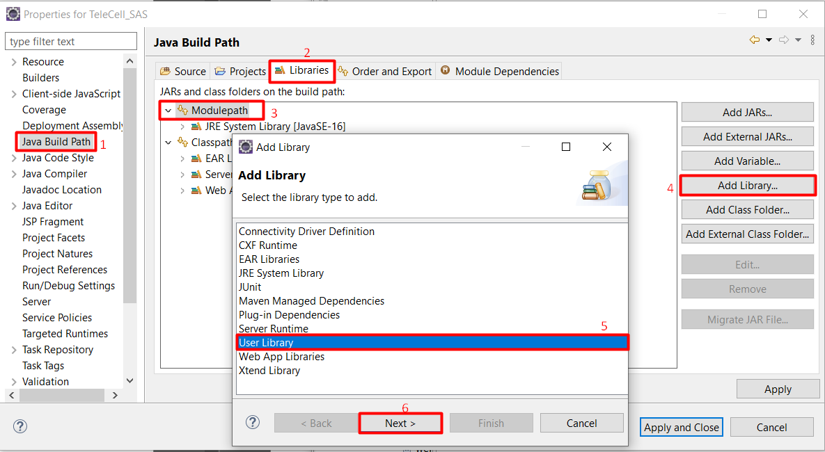
- After selecting User Library and clicking Next, follow the steps below.
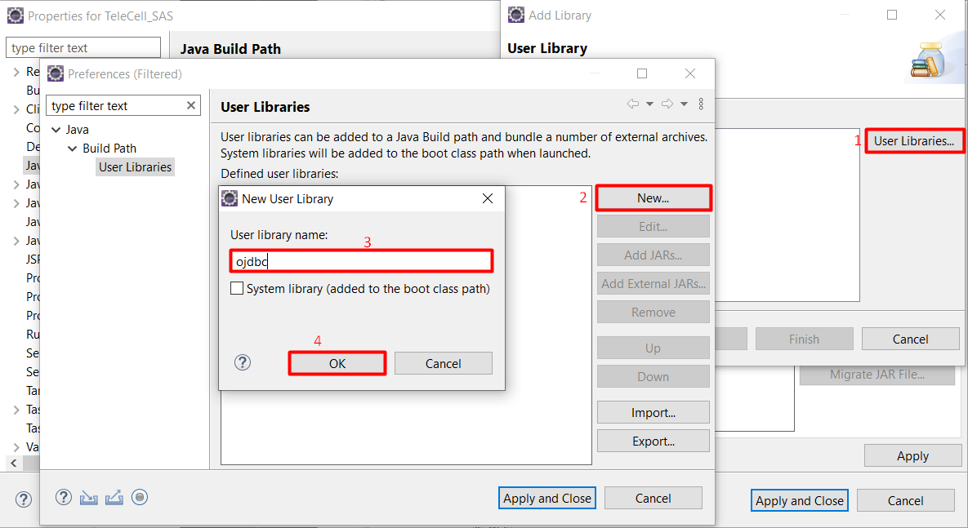

- Create a new User Library above, name it ojdbc and confirm. Then, click on the ojdbc library you created and press the Add External Jar's box as indicated below, and select and confirm the ojdbc8.jar file you downloaded.

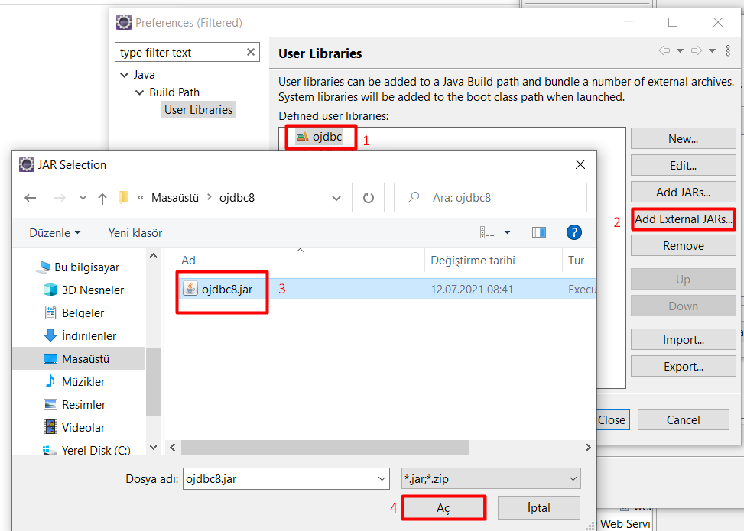

- Confirm the changes you have made after clicking on the library we have added as shown below and making sure that the files have been added.
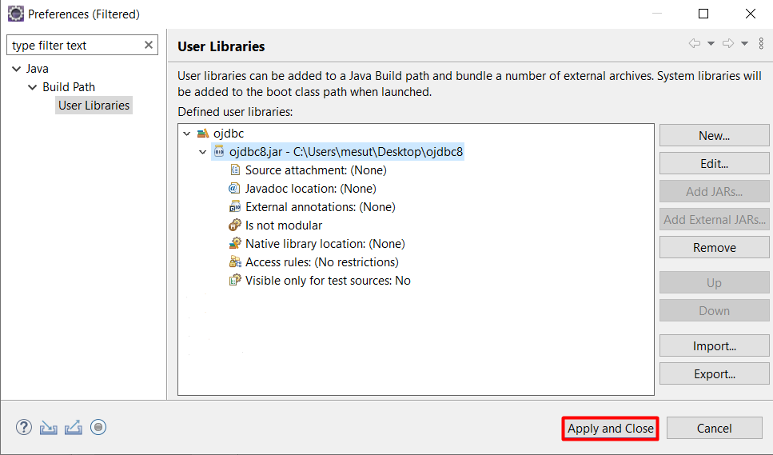
- Then right-click on the project file and click Properties, and then follow the steps given below.

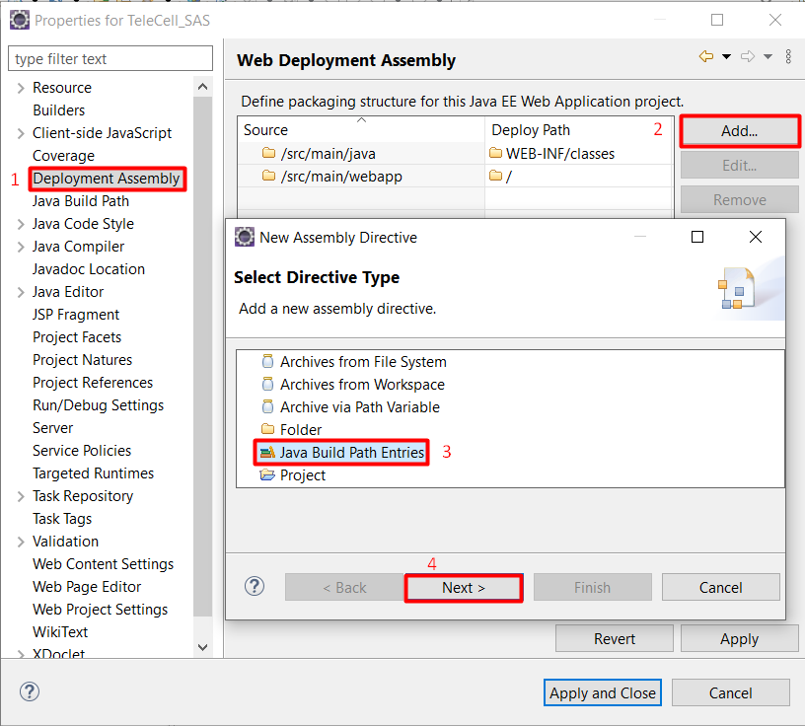
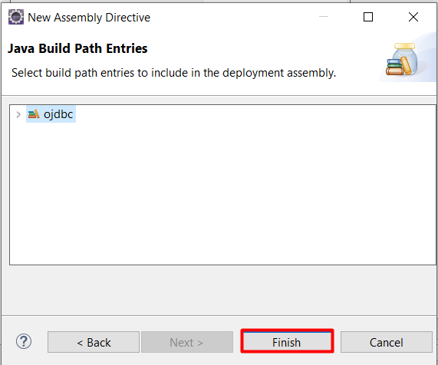
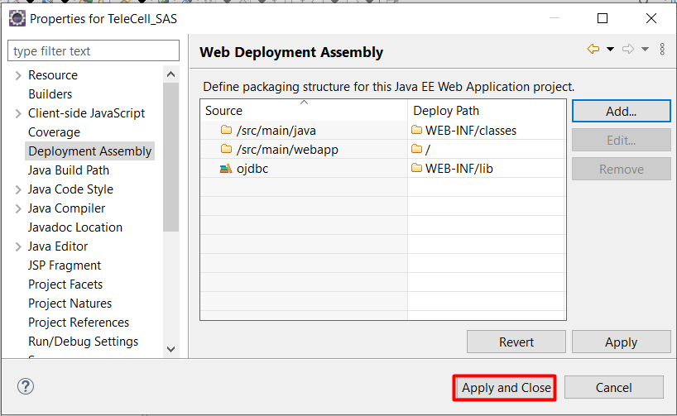

- By following the above procedures, you have met the necessary conditions to be able to connect with Oracle Database.
- Create Java Classes in the package, where we can write the necessary codes for Web Service.( The following is a visual example. In order to add Web Services, projects and classes with different names and contents will be continued.)

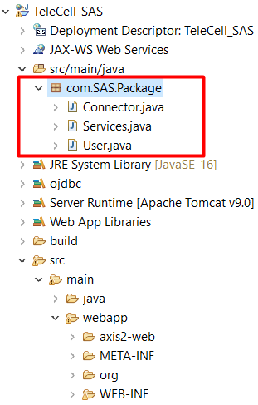

- The Web Service WSDL file should be added by right-clicking on the Package we created in our project. The pictures below show the steps to take.
- NOTE : If changes are made to the classes, the steps shown below should be repeated.
- NOTE-2 : First, install the Web Service directly from the next step. If the Web Service you have installed automatically generates the WSDL file, you do not need to do this step. If the WSDL file is not being created, you can continue by deleting the service and performing this step.

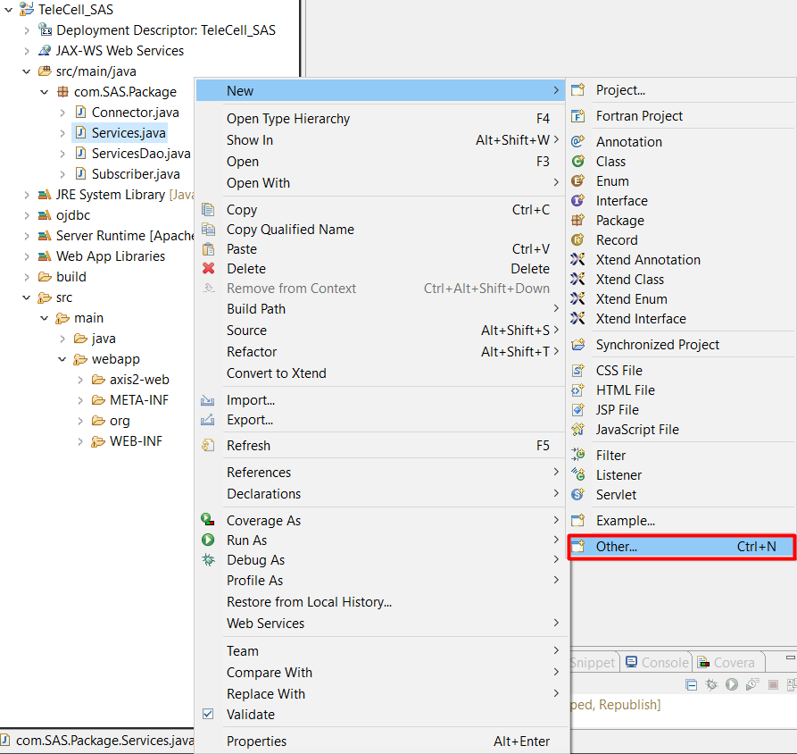

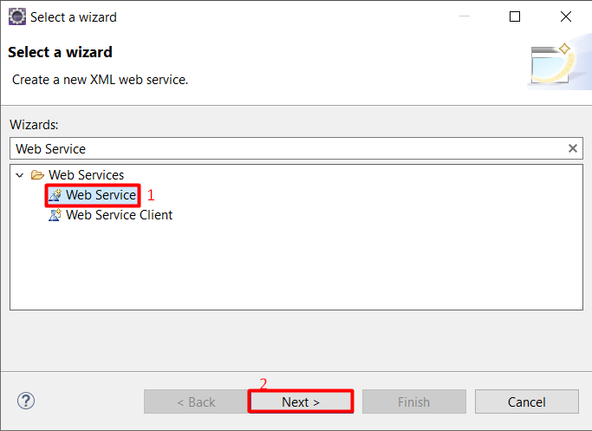

- After selecting Web Service and saying Next, make the following settings.
- First we create our WSDL file
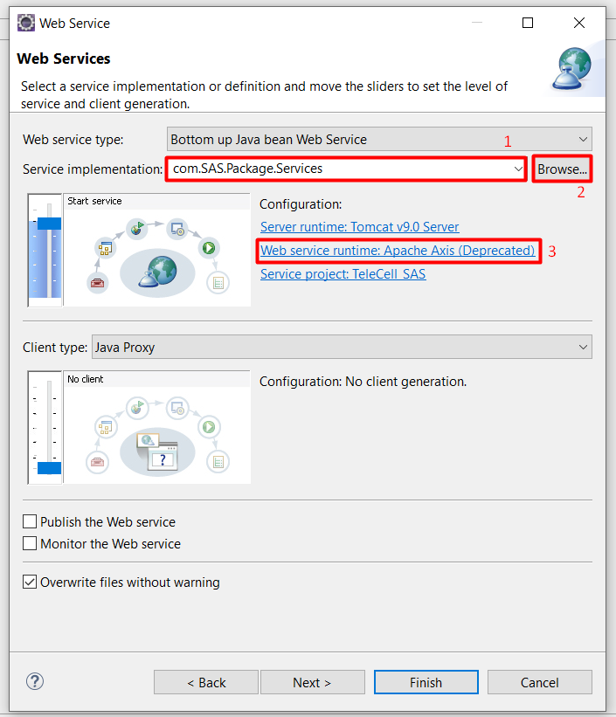
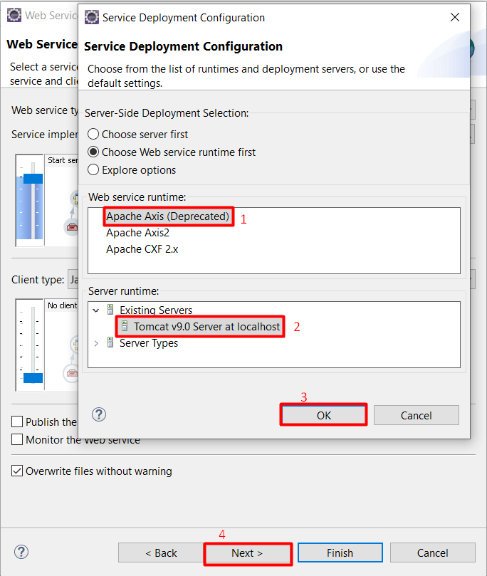

- After performing the above steps, click the Next button. Then click the Next button again to create the WSDL file and click the Cancel button in the window that appears. (The operations done here are to create a WSDL file.)

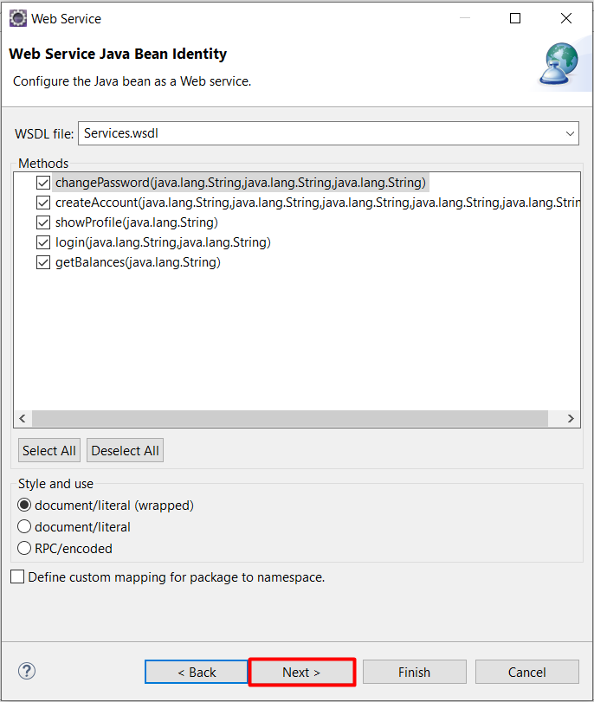

- Our WSDL file has been added.

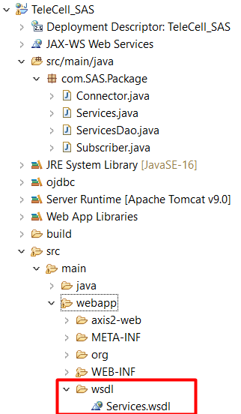

- Web Service should be added by right-clicking on the Package we created in the project. The pictures below show the steps to take.
- NOTE : If changes are made to the classes, the steps shown below should be repeated.

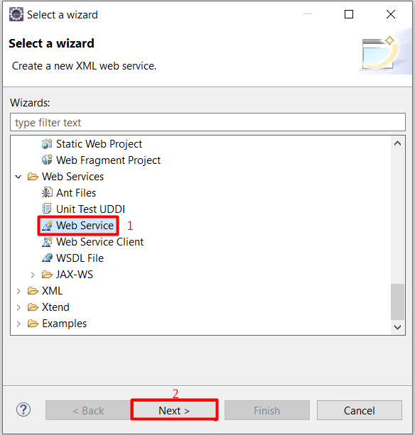

- After selecting Web Service and clicking the Next button, follow the steps given below in order.

- Browse to the class you want to add a service to and follow the necessary steps. Then press the Next buttons and then the Finish button.

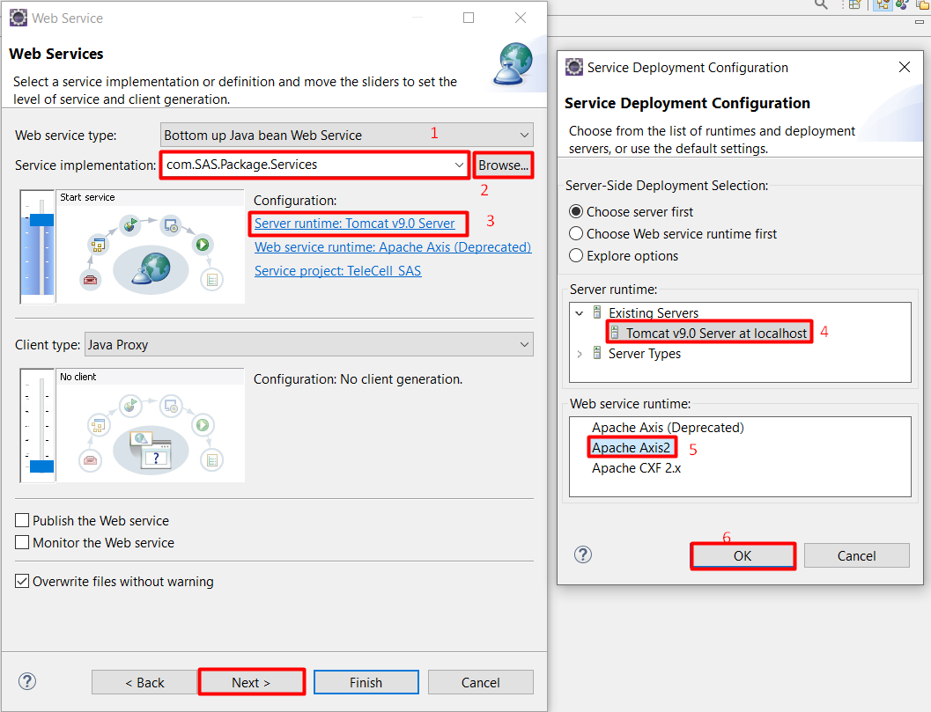

- Thus, you have added Web Service. After adding the Service, access and open the file whose directory is shown below.

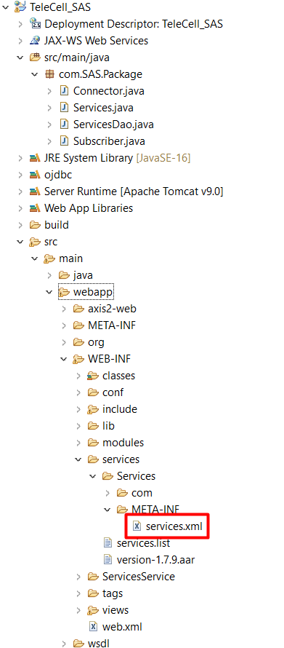

- Change the part below in this file as indicated in the next image.

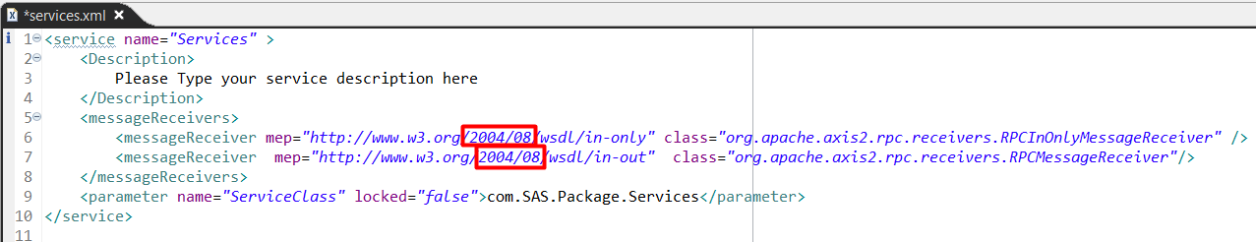

- Correct the selected part ( 2004/08 >> ns ) and save it as below.

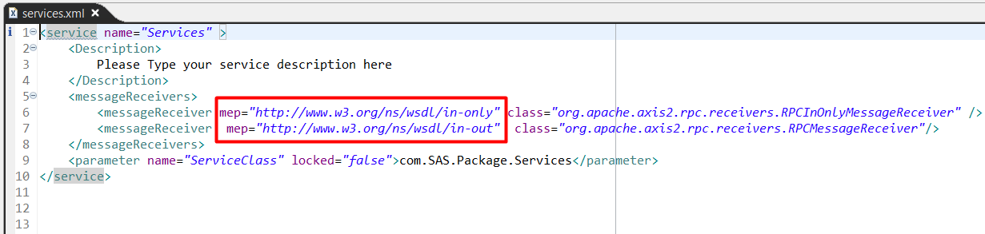

- After performing these steps, right-click on the project and click Run On Server from the Run As option to run the Web Service.
- Follow the steps below.

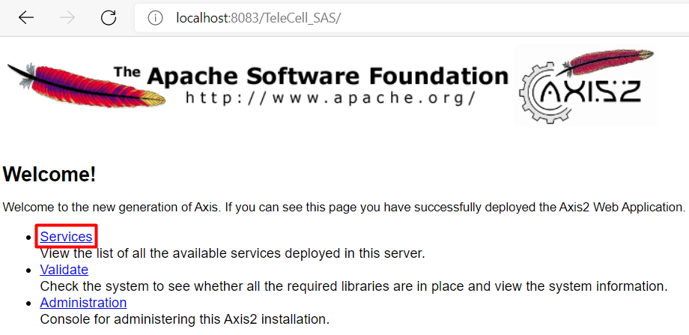
- After running it, click on the class you added Service on the page that opens as below.

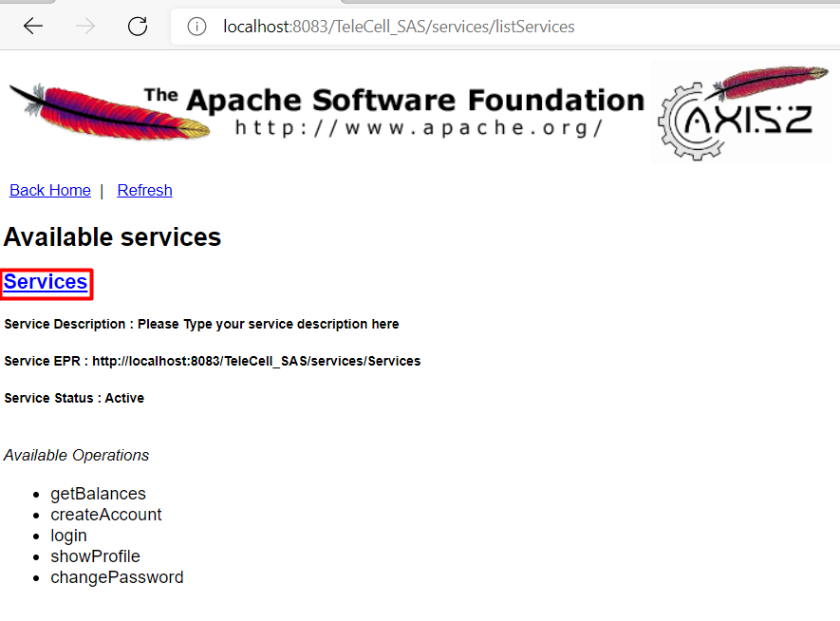
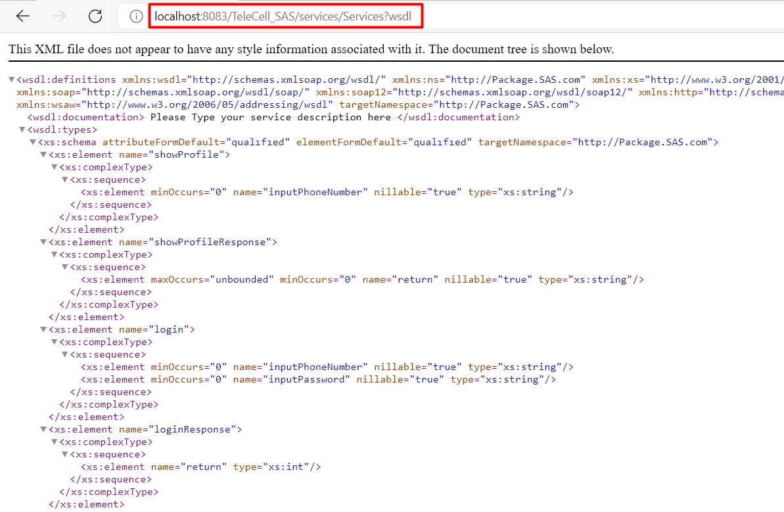

- Download SoapUI-5.6.0 Program to test the created Web Service. Then create a new Soap Project by saying New Soap Project. You can select the WSDL file you created in the project file by clicking the Browse button below on the screen that opens, or you can copy and use the WSDL link shown in the picture above. Then press OK.

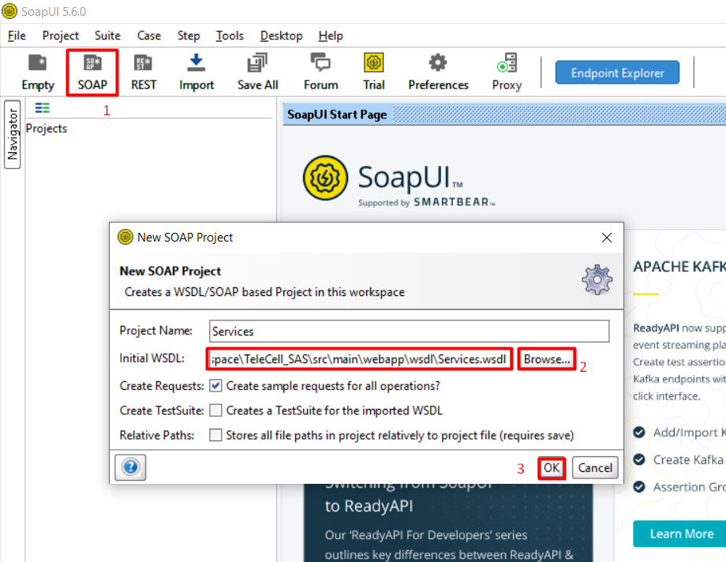

- You will be able to see the Functions you will use in the Service section of the Soap project you have created. To test it, go inside the functions and click Request.
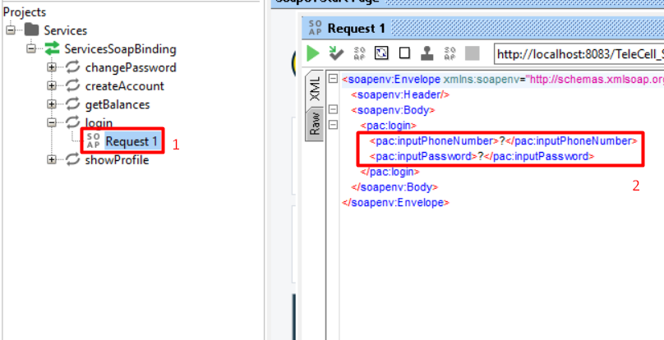

- The parameters taken by the functions above are ' ? ' is written instead. Run it as shown below. You can see the return value of the function you are running on the right side of the screen.

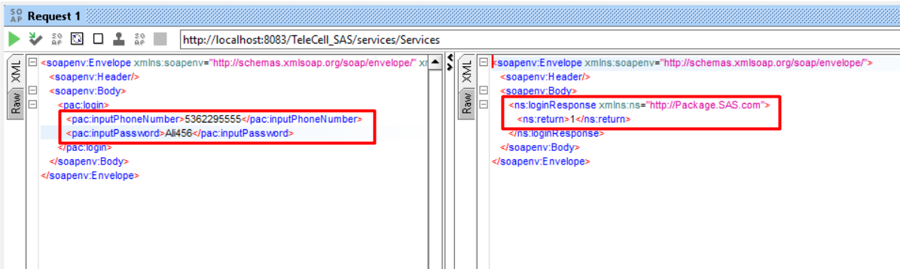

Login Service

Login service provided to grant login permission if the information of registered users in the database match, and deny login permission to unregistered users:
Module Properties | Property Details
Name | Login Service
Module Category  (Application / Library / Other ) | Application
Module Type  (PLSQL / EJB / WebService / Standalone / Library) | Web Service
Shipment Type  (JAR / EAR / WAR / BINARY EXE / SCRIPT / (UN)WRAPPED PLSQL) | War
Interaction Type  (Synchronous/Asynchronous) | Synchronous with TeleCell (Database)
DB Dependency | YES
Expected Latency | ~20ms
Access Level  (Public / Non-Public / 3rd Party) | Internal
Input | Login service
Output
Main Processing
Logic

Create User Service
Create User Service, which enables users who are not registered in the database to register:
Module Properties | Property Details
Name | Create User Service
Module Category  (Application / Library / Other ) | Application
Module Type  (PLSQL / EJB / WebService / Standalone / Library) | Web Service
Shipment Type  (JAR / EAR / WAR / BINARY EXE / SCRIPT / (UN)WRAPPED PLSQL) | War
Interaction Type  (Synchronous/Asynchronous) | Synchronous with TeleCell (Database)
DB Dependency | YES
Expected Latency | ~20ms
Access Level  (Public / Non-Public / 3rd Party) | Internal
Input | Create User Service
Output
Main Processing  Logic | 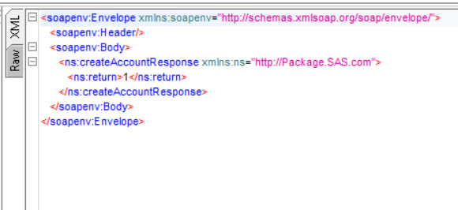  In case the data required for registration is not entered correctly (For example, entering more characters for the phone number.) The result is:

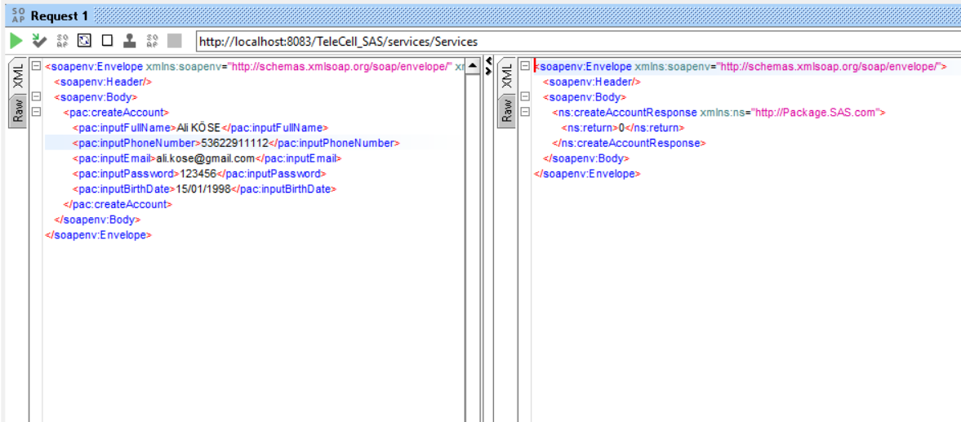

Get Balance Service
Service that allows users to view the remaining usage rights:
Module Properties | Property Details
Name | Get Balance Service
Module Category  (Application / Library / Other ) | Application
Module Type  (PLSQL / EJB / WebService / Standalone / Library) | Web Service
Shipment Type  (JAR / EAR / WAR / BINARY EXE / SCRIPT / (UN)WRAPPED PLSQL) | War
Interaction Type  (Synchronous/Asynchronous) | Synchronous with TeleCell (Database)
DB Dependency | YES
Expected Latency | ~20ms
Access Level  (Public / Non-Public / 3rd Party) | Internal
Input | Get Balance Service
Output
Main Processing
Logic

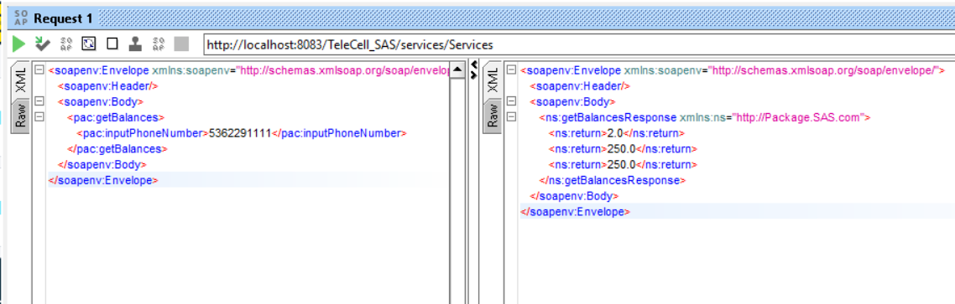

Show Profile Service
Service that allows displaying user information:
Module Properties | Property Details
Name | Show Profile Service
Module Category  (Application / Library / Other ) | Application
Module Type  (PLSQL / EJB / WebService / Standalone / Library) | Web Service
Shipment Type  (JAR / EAR / WAR / BINARY EXE / SCRIPT / (UN)WRAPPED PLSQL) | War
Interaction Type  (Synchronous/Asynchronous) | Synchronous with TeleCell (Database)
DB Dependency | YES
Expected Latency | ~20ms
Access Level  (Public / Non-Public / 3rd Party) | Internal
Input | Show Profile Service
Output
Main Processing
Logic

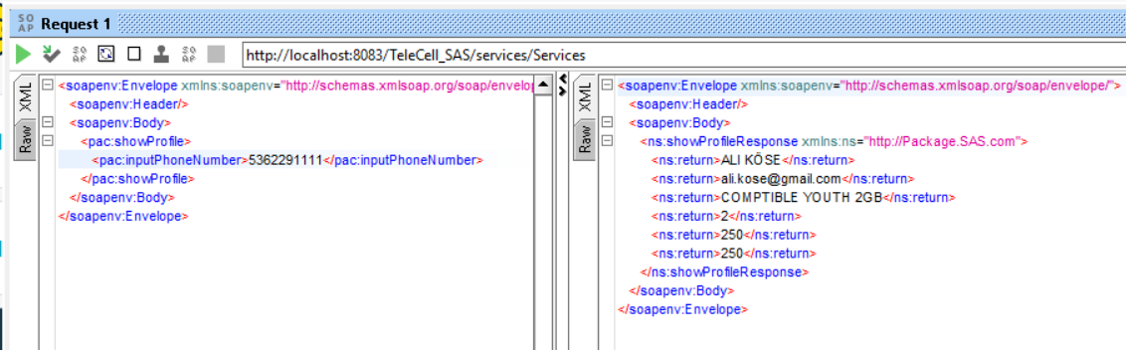

Change Password Service
Service that allows users to get a new password if they forget their password :
Module Properties | Property Details
Name | Change Password Service
Module Category  (Application / Library / Other ) | Application
Module Type  (PLSQL / EJB / WebService / Standalone / Library) | Web Service
Shipment Type  (JAR / EAR / WAR / BINARY EXE / SCRIPT / (UN)WRAPPED PLSQL) | War
Interaction Type  (Synchronous/Asynchronous) | Synchronous with TeleCell (Database)
DB Dependency | YES
Expected Latency | ~20ms
Access Level  (Public / Non-Public / 3rd Party) | Internal
Input | Change Password Service
Output
Main Processing
Logic

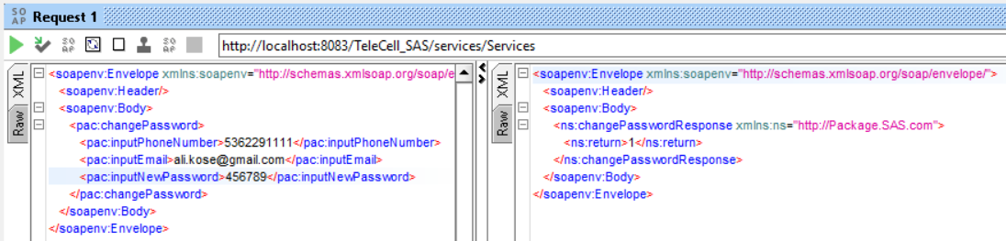

Interfaces & Integration

This section provides a list and a brief description of the software and communication interfaces supported by the system and/or used by components within the overall system/solution. Note that for the actual specification of each interface; please refer to the relevant interface specification document.

The below diagram provides the IDs of the critical interfaces used by relevant applications/modules within the overall solution/system design. If the integration architecture is quite complex, then, please use related integration architecture templates.

Interfaces and Integration Map

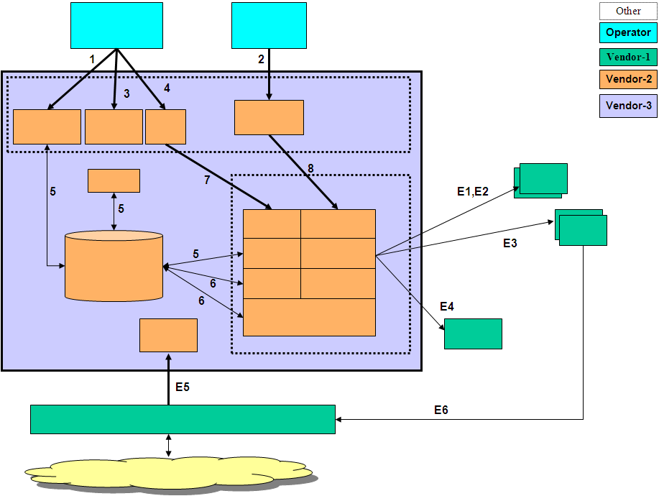
Figure 3: Interfaces and Integration Map

External Interfaces Map
This section provides a list of the interfaces provided by the systems outside the scope of the solution/system of our concern. In other words this section lists the interfaces that are external. For the actual specification of interfaces, please refer to relevant interface specification documents.

ID | Description | Source  Applications/  Modules | Destination  Applications/  Modules | Protocol | Client  Interaction Type | Frequency/  Response | Type | Interface  Packaging | Access  Level
E1 | … | … | … | RPC over TCP | Synchronous | 500ms | Realtime | Java APIs | Public
E2 | … | … | … | Web Service http-soap | Synchronous | <5sec | Online | Java APIs | Public
E3 | … | … | … | File Based  ASN.1 | Asynchronous, | 10 minutes | scheduled batch | N/A | Public
E4
E5
 | … | … | …

System/Solution Interfaces Map
This section provides a list of the publicly accessible and private interfaces provided by the system/solution. Note that since private interfaces are used internal and not supported, only the critical ones can be provided as additional information. For the actual specification of interfaces, please refer to relevant interface specification documents.

ID | Description | Source  Applications/  Modules | Destination  Applications/  Modules | Protocol | Client  Interaction Type | Frequency/  Response | Type | Interface  Packaging | Access  Level
1 | … | … | … | Web Service http-soap | Synchronous | <5sec | Online | Java APIs | Public
2 | … | … | … | Web Service http-soap | Synchronous | <5sec | Online | Java APIs | Public
3 | … | … | … | File Based  ASN.1 | Asynchronous, | 10 minutes | scheduled batch | N/A | Public
4
…
7 | … | … | … | ASCII over TCP | Synchronous | <300ms | Realtime | C shared library | Private

Deliverables Portfolio; Applications and Libraries

This section provides a list of deliverables from deployment perspective where a list of all i2i developed and/or 3rd party application and libraries is to be provided.

i2i developed Applications and Libraries
Name | Description | Module Category  (Application/  Library) | Shipment Type
APRMWEB | View Layer and Basic Controller. Set of ZUL files and basic controller related Java classes on View Layer. | APPLICATION | EAR
APRMWS | APRM Web Service | APPLICATION | EAR
REQIF | Request Interface RMI Gateway | APPLICATION | JAR
TMF | Transaction Mgmt Function | APPLICATION | JAR
INT-E | Integration Engine | APPLICATION | JAR
BACH | Batch Operations Handler | APPLICATION | JAR
GDR.xsd  GDR.jar | Generic Data Record XML Schema Specification | LIBRARY | JAR
TXDR.xsd  TXDR.jar | Transaction Data Record XML Schema Specification | LIBRARY | JAR
ENTITY.xsd  ENTITY.jar | Entity XML Schema Specification that holds all PRM related entity object model; Dealer, Position, User etc. used for transport of all business value objects over Web Service, RMI and JMS layers. | LIBRARY | JAR
CHARSPEC.xsd  CHARSPEC.jar | Screen Objects and characteristics XML Schema Specification | LIBRARY | JAR
I2iCommon.xsd  I2iCommon.jar | Common Value Object types | LIBRARY | JAR
WORKFLOW.xsd  WORKFLOW.jar | Workflow Model XML Schema Specification | LIBRARY | JAR
WFELib  (wfecore.jar and  wfeTMF.jar) | Workflow Library providing workflow API | LIBRARY | JAR
BIZLib.jar | Business Library that provides all DB layer related update logic | LIBRARY | JAR
EFELib.jar | Enterprise Function Evaluator Library that provides a configurable action processing framework used by INT-E and WFELib | LIBRARY | JAR
INT_DSF.jar | DSF Integration Plug-In Functions API functions that implement EFE interfaces | LIBRARY | JAR
INT_INFODEALER.jar | INFODEALER Integration Plug-In Functions API functions that implement EFE interfaces | LIBRARY | JAR
INT_OM.jar | OM Integration Plug-In Functions API functions that implement EFE interfaces | LIBRARY | JAR
INT_BSCS.jar | BSCS Integration Plug-In Functions API functions that implement EFE interfaces | LIBRARY | JAR
INT_MERNIS.jar | MERNIS Integration Plug-In Functions API functions that implement EFE interfaces | LIBRARY | JAR
INT_SAP.jar | SAP Integration Plug-In Functions API functions that implement EFE interfaces | LIBRARY | JAR
INT_LDAP.jar | LDAP Integration Plug-In Functions API functions that implement EFE interfaces | LIBRARY | JAR
INT_LDAP_DEALER.jar | Dealer LDAP Integration Plug-In Functions API functions that implement EFE interfaces | LIBRARY | JAR
MAIL.jar | MAIL sending Plug-In Functions API functions that implement EFE interfaces | LIBRARY | JAR
WFE_FUNC.jar | Other WFE related Plug-In API functions that implement EFE interfaces | LIBRARY | JAR
dtflib.jar  DecisionTreeSchema.jar  DecisionTreeSpecification.jar | Decision Tree Library that allows configurable message routing and determination of workflow transition and selection rules | LIBRARY | JAR
Mxlib.jar | Message Exchange Library for configurable inter-application message routing | LIBRARY | JAR
ithreadpool.jar | Configurable multi-threaded and reliable application framework | LIBRARY | JAR

3rd Party Applications and Libraries
The below table depicts the most critical 3rd party libraries used by the System/Solution. Since versions may change at time of deployment, they are not provided.

Name | Description | Module Category  (Application/  Library) | Shipment Type
Axis.jar | Apache Axis related to web services | LIBRARY | JAR
Commons-xxx.jar | Apache commons libraries;  - Commons-logging  - Commons-cli  - Commons-dbcp  - Commons-dbutils  - Commons-lang  - Commons-pool  - Commons-beanutils | LIBRARY | JAR
Junit.jar | JUnits related JAR | LIBRARY | JAR
Log4j.jar | Logging related JAR | LIBRARY | JAR
Saxon9he.jar  Saxpath.jar | XML processing related JAR | LIBRARY | JAR
Xbean.jar  Xbean.xpath.jar | XML Beans related JAR | LIBRARY | JAR
Pop3.jar  Smtp.jar  Mailapi.jar | Mail related JAR | LIBRARY | JAR
Velocity.jar | Template driven development JAR  Used for email templates and other integration purposes | LIBRARY | JAR
Telnetd.jar  Dsn.jar | TCP/IP based communication JAR | LIBRARY | JAR

Appendix

Document Control

Superseded Documents
- N/A

Change Control & Distribution
Owner | I2i Systems
Reviewer | Mennan TEKBİR
Approved By
Distribution
File Name | 0000.doc

Version History
Version | Change Descriptions | Author | Date
1.0.0 | Initial Version | Ali KÖSE | 27/07/2021

Approvals
This document requires the following approvals:

Name | Title | Date | Signature | Version

